

Members

**1**

JOSE ENRIQUE CRISOSTOMO





Objectives:

1

. To provide a wearable technology that can

track the location of your loved ones in real-time.

2

. To enhance the safety and security of your

loved ones by allowing you to monitor their

whereabouts

. 3. To increase the communication and

connection between family members by utilizing

the ring's tracking feature.

4

. To offer peace of mind to individuals who have

elderly or young family members that require

supervision.

5

. To create a functional and stylish accessory

that serves both practical and sentimental

purposes.

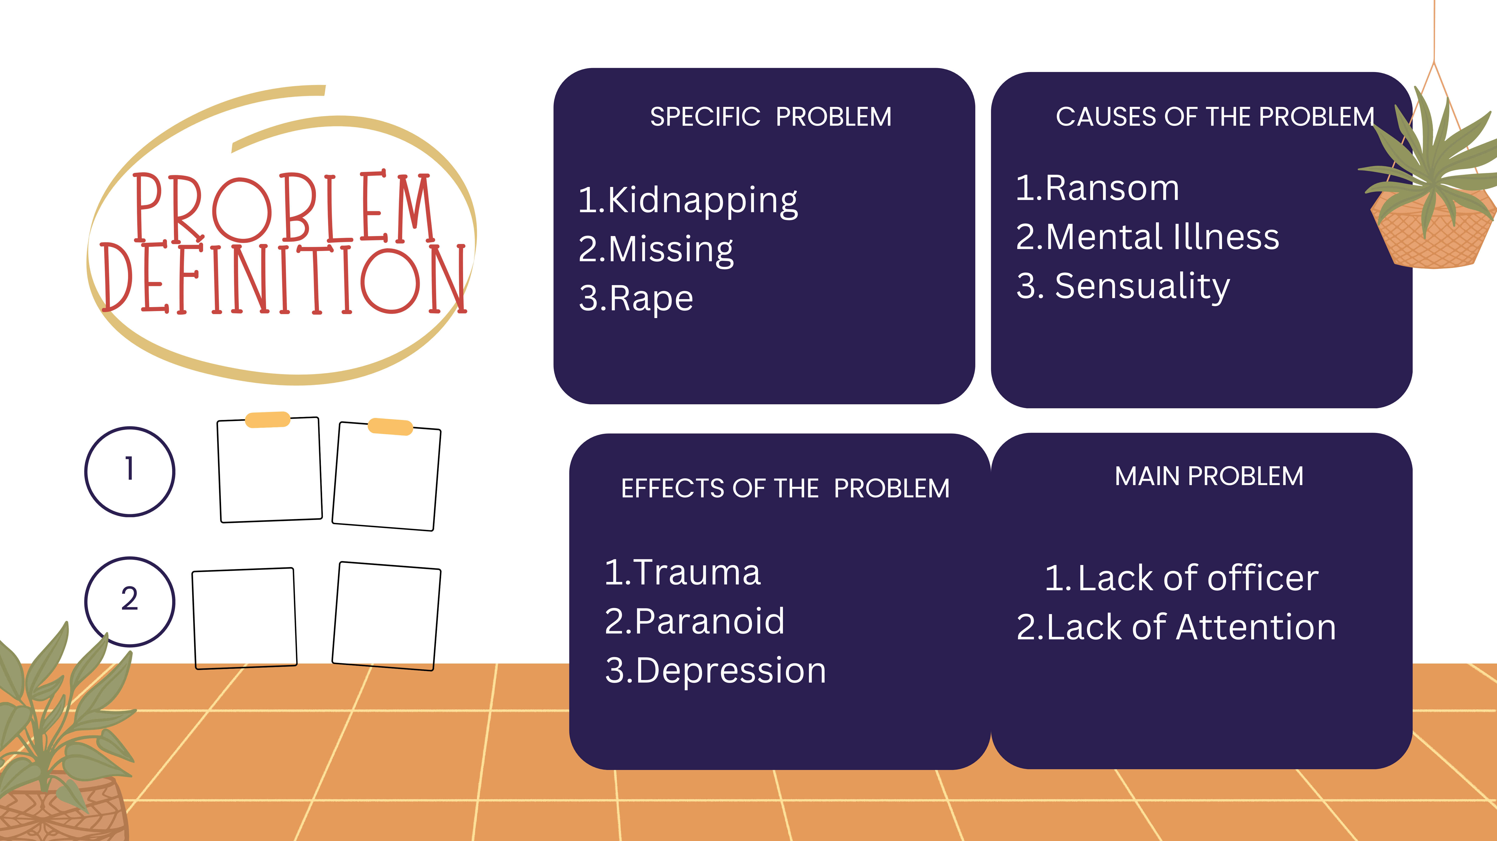



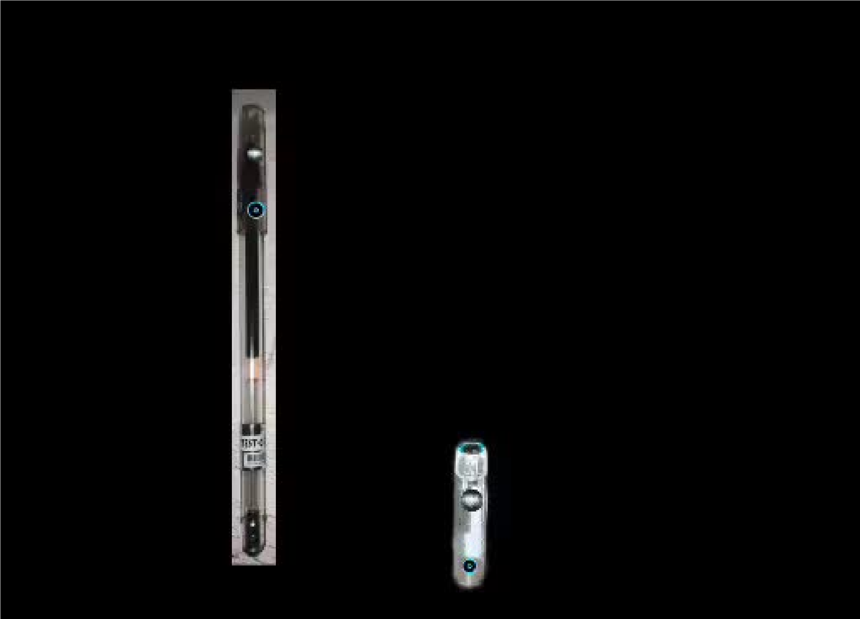

Objectives:

We should pursue this product because it can

greatly enhance productivity and creativity by

allowing individuals to quickly capture and save

their thoughts and ideas without the need for

traditional pen and paper. It also offers the ability

to easily share ideas digitally and collaborate

with others, making it a valuable tool for both

personal and professional use.

